TO CREATE HTTPS SERVICE:

Keytool command: to download jks file type this command in command prompt

keytool -genkeypair -keystore mule.jks -dname "CN=localhost, OU=Unknown, O=Unknown, L=Unknown, ST=Unknown, C=Unknown" -keypass password -storepass password -keyalg RSA -sigalg SHA1withRSA -keysize 2048 -alias mule -ext SAN=DNS:localhost,IP:127.0.0.1 -validity 9999

Step2: copy and paste the jks file which is available in **windows-user-admin-keystore.jks**  in ANYPOINT studio under **src-main-resource**

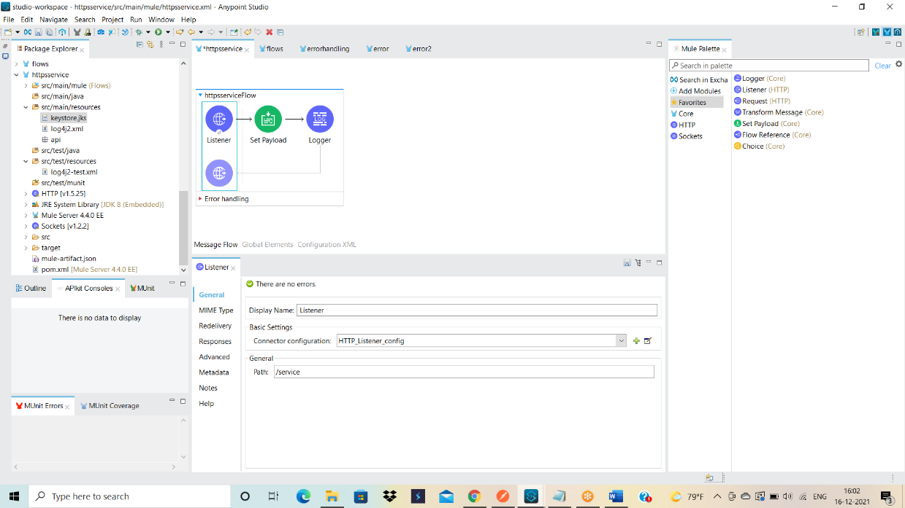

Step3: LISTNER PROPERTIES CONFIGURATION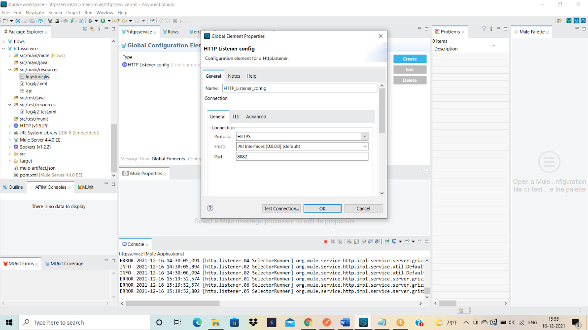

UNDER TLS

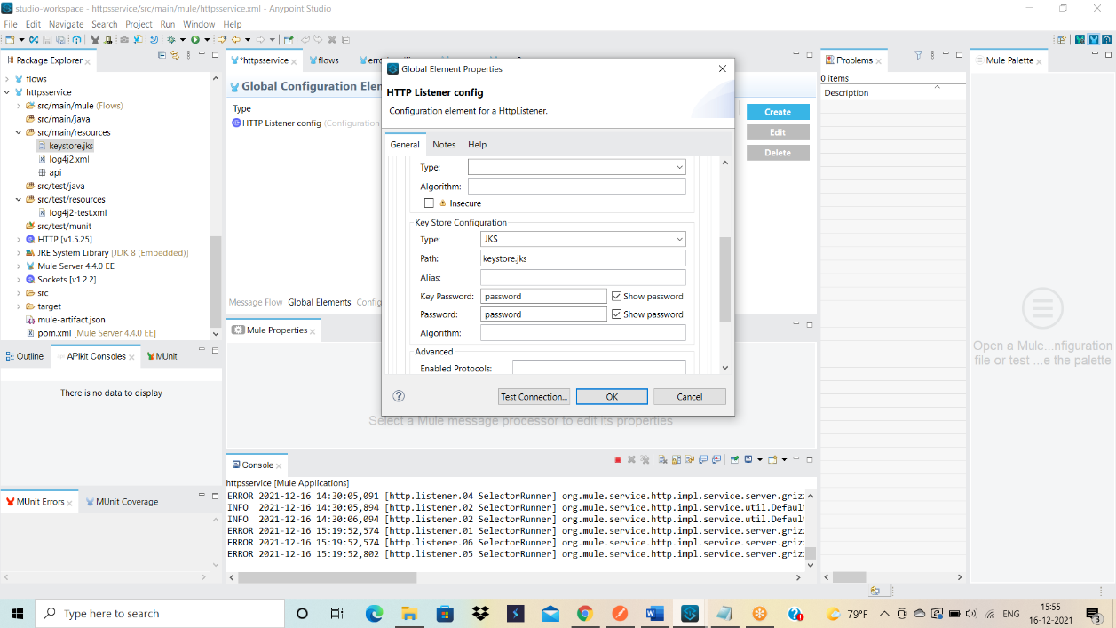

STEP4: RUN your mule application and DEPLOY to RUNTIME MANAGER to get secured url.